CIVIL DOCTOR

TECHNOLOGY USED : REACT JS, NODE JS.
CLOUD: CLOUDINARY
AUTHENTICATION: FIREBASE FOR ADMIN
DEPLOYED IN VERCEL
DEMO SITES
1.27/1/26 ROUGH UI DESIGN
https://project-1-phi-kohl.vercel.app/
https://civil-bice-eta.vercel.app/
2.DRAFT 7/2/26
https://civil-cbof.vercel.app/
3 DRAFT WITH ADMIN ACCESS
https://civil-foag.vercel.app/
EMAIL : admin@civildoctor.com
PASSWORD: Admin@123456

CONTENT
HOME PAGE
🏠 Civil Doctor – Home Page Content
Welcome Message
WELCOME TO CIVIL DOCTOR
Civil Doctor undertakes all types of specialty construction works, including:
- Waterproofing of roofs, basements, sunken areas, overhead water tanks, underground sumps, and swimming pools
- Structural rehabilitation (restoring old buildings, spalled roof treatment, beams and column treatment)
- Sealant application along expansion joints
- Industrial hard flooring systems, epoxy flooring systems
- Injection pressure grouting
- Bituminous felt laying works

🧱 Our Services
Waterproofing
- Roof
- Sunken Slab
- Overhead Tank
- Roof Garden
- Basement
- Sump
- Swimming Pool
- Retaining Structure
Protective Coatings
- Crystallisation Coatings
- Impregnation Coating (Silance Siloxane)
- Injection Pressure Grouting
- Integral Waterproofing Admixtures
- Acrylic Polymer Coatings
- Bituminous Felt Laying
- Polyurethane Coatings
- Bituminous Coatings
Flooring
- Storage & Logistics
- Clean Rooms (Hospitals, Pharma Industries)
- Production / Packing Areas
- Engineering Workshops
- Parking Areas
Repair & Rehabilitation
- Thermal Insulation
- Roof Surki
- Sunken Filling
- Fire Protection
- Sound Deadening Medium
CIDOMLITE
- Thermal Insulation
- Roof Surki
- Sunken Filling
- Fire Protection
- Sound Deadening Medium
Joint Sealants
- Expansion / Construction Joints
- Structural Glazing
- Windows & Doors Perimeter
- Silicone Sealants
- Polyurethane Sealants
- Polysulphide Sealants
- Acrylic Sealants

🎥 Media & Contact Section
- Company Video (embedded on page)
Quick Contact
- Phone: +91-9894600048
- Phone: +91-9894171051
- Options to Send SMS or Send E-mail directly from the page

📍 Contact Information
CIVIL DOCTOR
#12/20, SND Layout No II,
Tatabad, Coimbatore-641012
- Call-Us: +91-9894600048
- Call-Us: +91-9894171051
- Contact via Email link on the page

📌 Footer
- Navigation links: Home | About Us | Services | Products | Clients | Contact Us
- Copyright © 2015 Civil Doctor. Designed and Hosted by Inway
ABOUT US
🏢 About — Civil Doctor
Civil Doctor was established in 1998 and is a leading company specializing in construction-related products and services like:
- Specialty epoxy flooring adhesive
- Construction joint sealants
- Bitumen waterproofing
- Crystalline waterproofing
- APP waterproofing membrane
- Injection grouting
- Epoxy flooring
- Expansion joint sealants
- Repair and rehabilitation services
They also have a branch in Chennai.

🎯 Vision
To be a pioneer in sustainable specialty construction chemicals, waterproofing, and epoxy floorings by providing the highest quality and effective services through:
- Professional and efficient approach
- Ethical business practices
- Continuous research and development
- Utilization of new product technologies

📌 Mission & Core Values
Civil Doctor emphasizes the following values:
Discovery – bringing new knowledge and better business methods
Creativity – innovation in work
Excellence – delivering high-quality products and services
Diversity – valuing differences
Integrity – acting with responsibility
Service – benefiting the public and stakeholders
If you have a problem, we have the solution.

📊 Basic Company Info
- Company Name: Civil Doctor
- Services: Waterproofing, Protective Coatings, Flooring, Cidomlite, Joint Sealant
- Registration Type: Partnership
(Listed on the site’s about section)

💼 Types of Services Listed
✔️ Waterproofing
- Roof
- Sunken Slab
- Overhead Tank
- Roof Garden
- Basement
- Sump
- Swimming Pool
- Retaining Structure
✔️ Protective Coatings
- Crystallisation Coatings
- Impregnation Coating (Silance Siloxane)
- Injection Pressure Grouting
- Integral Waterproofing Admixtures
- Acrylic Polymer Coatings
- Bituminous Felt Laying
- Polyurethane Coatings
✔️ Flooring
- Storage & Logistics
- Clean Rooms (Hospitals, Pharma Industries)
- Production/Packing Areas
- Engineering Workshops
- Parking Areas
✔️ Repair & Rehabilitation
(Listed categories, same as above)
SERVICES
1. WATER PROOFING
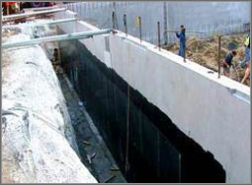
Civil Doctor, the world's leading waterproofing company has been producing innovative and high quality waterproofing products since 1998. Whether the project is new construction, renovation or restoration, we are available for consultation before, during and after the construction process. Early involvement with architect, engineers and contractors minimizes risks and ensures compatible specifications can be met. Moreover, the process can also result in beneficial value engineering solutions and cost savings to the client.
Waterproofing Applications
- Waterproofing for RCC Roofs and Sunken Slabs, AC sheet roofs and gutters.
- Waterproofing for overhead water tanks, underground water tanks, sumps, underground parking decks and basement cellars.
- Waterproofing for toilets (sunken portions)
- Waterproofing for retaining structure and Roof Garden
- Waterproofing of Swimming pools.
Assured Quality and Services!!!
2. PROTECTIVE COATINGS
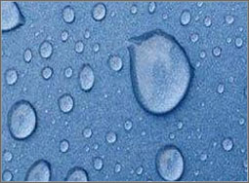
We are a trusted name for offering a huge collection of surface coating products including Civil Doctor. The coatings are used for safeguarding, deep sealing, refurbishing and effective protection for synthetic and soft wood. They are very efficient for providing the surfaces with proper sealing against water, moisture and dust. The coatings also protect materials from scratches and abrasions.
Systems
- Protective coating for Effluent treatment plants (ETP), acid storage tanks, Laboratories.
- Acid and chemical resistant coating for chemical, food processing and pharmaceutical industries.
- Crystallisation Coatings
- Impregnation Coating (Silane Siloxane)
- Injection Pressure Grouting
- Integral Waterproofing Admixtures
- Injection Pressure Grouting
- Acrylic Polymer Coatings
- Bitumenous Felt Laying
- Polyurethane Coatings
- Bitumenous Coatings
Assured Quality and Services!!!
3. FLOORING
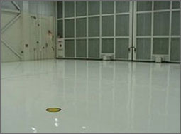
We have been able to offer high quality Industrial Flooring to our valuable customers. These services are highly appreciated among our customers for their cost effectiveness, customization and execution within the assured time frame. To effectively execute these services, we have appointed a team of skilled technicians and other supporting staff. The product is extremely durable and meant to serve for ages. It is exceptional in adhesion and perfectly smooth. It can be cleaned easily and is resistant to reaction with chemicals. The flooring supplied by us is monitored for quality and is defect free in nature.
Application
- Floor hardening for industries.
- Heavy-duty machinery beds and foundations.
- Epoxy floor coating for showrooms, dairies, bakery, hospitals and engineering plats.
- Gangway marking.
- Storage & Logistics
- Clean Rooms - Hospitals, Pharma Industries
- Production / Packing Area
- Engineering Workshop
- Parking Areas
Assured Quality and Services!!!
Our Services
Water Proofing Protective Coatings Flooring
Storage & Logistics Clean Rooms - Hospitals, Pharma Industries Production / Packing Area Engineering Workshop Parking Areas
Repair & Rehabilitation Cidomlite Joint Sealant
4. REPAIR & REHABILITATION
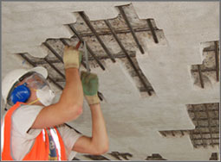
Our Civil Doctor is involved in rendering highly effective Building Repair and Rehabilitation Services to the respected clients. Our clients can avail these services from us at the affordable prices. We provide our services bridges constructions railways over bridges, ports and harbors. We offer our range of structural repair services adhering to meet the needs and requirements of both commercial as well as privately owned properties.
Advantages
- Increase the life and compressive strength of the structure
- Thermal Insulation
- Roof Surki
- Sunken Filling
- Fire Protection
- Sound Deadening Medium

Application
- Anti-Corrosive Treatment
- Bonding Agent (Old Concrete with New Concrete)
- Micro Concreting
- Impregnation Corrosive Inhibitor
Assured Quality and Services!!!
5. EXPANSION / CONSTRUCTION JOINT SEALANT
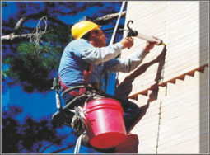
We are leading manufacturer and trader of an excellent quality Joint Sealing Compound. The offered product is manufactured in compliance with international quality standards using premium quality raw material and latest technology. Our quality controllers stringently test this joint sealing compound on various quality parameters to ensure high quality. Besides, our client can avail this joint sealing compound at nominal prices.
Application
- Expansion Joints, Construction Joints application
- Sealing joints in ceramic tilling sanitary wares, kitchens and glazing applications.
- Sealing joints along the perimeter of doors, windows, etc.
- Joint Sealant
- Expansion / Construction Joints
- Structural Glazing
- Windows, Doors Perimeter
- Silicone Sealants
- Polyurethane Sealants
- Polysulphide Sealants
- Acrylic Sealants

Systems
- Silicone Sealants
- Polyurethane Sealants
- Polysulphide Sealants
- Acrylic Sealants
Assured Quality and Services!!!
6. CIDOMLITE (Light Weight Filling Material)
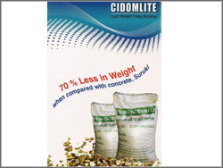
CIDOMLITE is the geological name given to a group of hydrated laminar minerals which are aluminium iron magnesium silicates resembling mica in appearance. Minute layers of water are trapped between the plates, and when the particles are subjected to heat they have the unusual property of exfoliating, or expanding, due to the inter-laminar generation of steam.
Characteristics
- Low density
- Low thermal conductivity
- High temperature resistance
- High absorbency
- High specific surface area
Application
- Thermal Insulation
- Roof Surki
- Fire Protection
- Sound Deadening Medium
pH
- 7.0 to 8.0
Loose Bulk Density
The loose bulk density of CIDOMLITE is normally in the range of 100-200 Kg/m3 and is influenced by the particle size and method of processing.
Incombustibility
- CIDOMLITE is incombustible and can be used up to 1,100oC.
Sintering Temperature
- About 1,260oC (2,300oF)
Melting Point
- About 1,315oC (2,400oF)
Specific Heat
- 0.2
Insolubility
CIDOMLITE is insoluble in water and organic solvents.
Absorption Capacity
CIDOMLITE will readily hold liquids within the inter-laminar voids of particles. It will also hold a certain amount between the individual particles. Water retained as a percentage of the air dry weight will be approximately 240%
Thermal Conductivity
CIDOMLITE has low thermal conductivity and high thermal insulation properties. The thermal conductivity at normal atmospheric temperatures:
K=0.43 – 0.45 Btu in/ft2hoF
K=0.062 – 0.065 W/moC
Uses
- Lightweight filling material
- Sunken, Surki Filling
- Heat and Sound Insulation
- Fireproofing Materials
- Furnace Linings
- Absorption of liquids and gases
- Carrier for chemicals and catalysts
- Hydroponics
- Carrier for water and nutrients in plant growing media
- Soil conditioning
- Effluent treatment
- Absorption of liquid spillages
- Fillers for plastics and paints
- Decorative finishes
- Packaging material
Assured Quality and Services!!!

PRODUCTS
PRODUCTS
Supreme Expansion Boards, Insu-reflector, Insu-shield, Insu-board
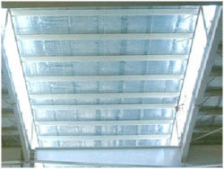
We are engaged in distributing and supplying Insu Reflector. These insulation reflectors are manufactured by using polyethylene air bubble film (ABE) laminated with aluminum foil.
Backer Rods, Thermal Insulators
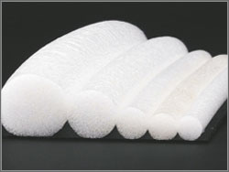
We are offering a wide range of Backer Rods and Thermal Insulators which is used extensively for filling up accidentally vacant holes in aluminium doors, windows and structural glazing projects.
Light Weight Filling Material
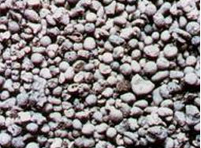
We are offering a wide range of Light Weight Filling Material which is used extensively for filling Construction of quay walls. These are manufactured using premium quality raw material and are available in market at industry leading prices.
Water Stoppers
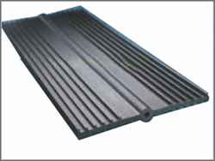
We have carved a niche for ourselves in this domain by offering best grade Water Stopper. Offered water stoppers also help in saving water as these are efficient in instant prevention of water seepage.
Concrete/Mortar Waterproofing Admixtures
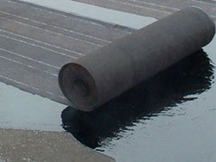
We are offering a wide range of Concrete/Mortar Waterproofing Admixtures. These are manufactured using premium quality raw material and are available in market at industry leading prices.
Acrylic/Polymer Crack Filler
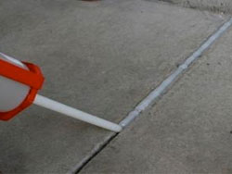
We are offering a wide range of Acrylic/Polymer Crack Filler. These are manufactured using premium quality raw material and are available in market at industry leading prices.
Mould release Agents, Curing Compounds
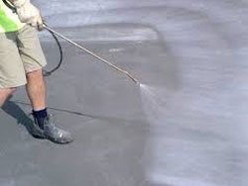
We are offering a wide range of Mould release Agents, Curing Compounds. These are manufactured using premium quality raw material and are available in market at industry leading prices.
Polymer Modified Repair Mortars
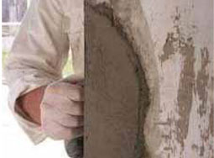
We are offering a wide range of Polymer modified repair mortars. These are manufactured using premium quality raw material and are available in market at industry leading prices.
Polymer Modified Water Resistant and Bonding Agents
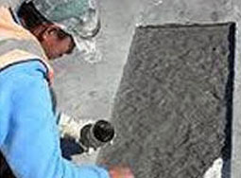
We are offering a wide range of Polymer modified water resistant and bonding agents. These are manufactured using premium quality raw material and are available in market at industry leading prices.
Acrylic and Polymer Modified Flexible Waterproofing Membrane
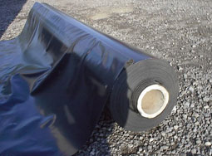
We are offering a wide range of Acrylic and Polymer modified flexible waterproofing membrane. These are manufactured using premium quality raw material and are available in market at industry leading prices.
Self Adhesive Waterproofing, Thermal Insulation, Sound Proof Membrane
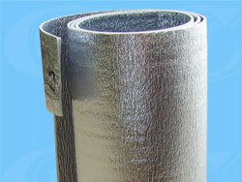
We are offering a wide range of Self adhesive waterproofing, thermal Insulation, sound proof Membrane. These are manufactured using premium quality raw material and are available in market at industry leading prices.
Expanding Grout Admixtures
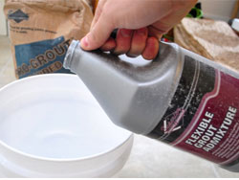
With the assistance of our professionals, We have been able to provide our clients with Expanding grout admixtures. These components are high flowing grouts are suitable for equipment base-plate grouting.
Non-shrink Free Flow Grouts
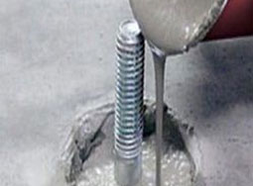
With the assistance of our professionals, We have been able to provide our clients with Expanding Non-shrink free flow grouts . These components are high flowing grouts are suitable for equipment base-plate grouting.
Tile Fixing/ Tile Over Tile Laying Adhesives
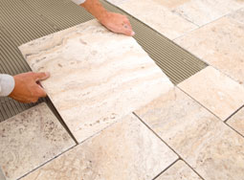
Fix tiles in kitchen, living rooms… on floors or walls whatever the substrates, the type or the size of tiles. Civil Doctor provides the right solution that guarantees long lasting adhesion and best workability for the users.
Waterproofed Filler Materials
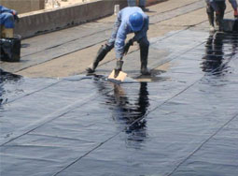
We are offering a wide range of Waterproofed filler materials. These are manufactured using premium quality raw material and are available in market at industry leading prices.
Bonding Agents, Repair Mortars
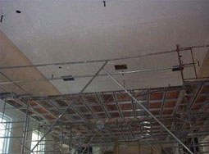
Whether the problem is new build defects, age related deterioration and everything in between, Civil Doctor offers a comprehensive range of Bonding agents and Repair Mortars.
Anti-Skid, Smooth Top Self-leveling Epoxy Floorings
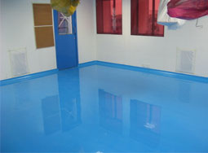
We are offering a wide range of Anti-Skid, Smooth top self-leveling epoxy floorings. These are manufactured using premium quality raw material and are available in market at industry leading prices.
Industrial Flooring Systems
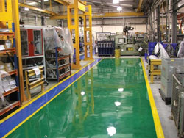
We are offering a wide range of Industrial Flooring Systems. These are manufactured using premium quality raw material and are available in market at industry leading prices.
Protective/ Chemical Resistant Coating
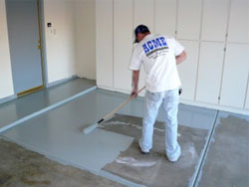
We are offering a wide range of Protective/ chemical resistant coating. These are manufactured using premium quality raw material and are available in market at industry leading prices.
Polyurethane, Polysulphide, Acrylic, Silicon Sealants
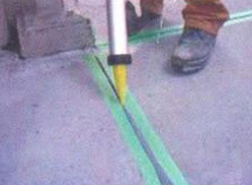
We are offering a wide range of Polyurethane, Polysulphide, Acrylic, Silicon Sealants. These are manufactured using premium quality raw material and are available in market at industry leading prices.
Anchor Grouts
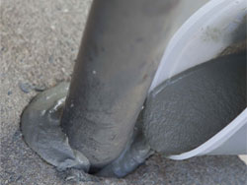
We are offering a wide range of Anchor Grouts. These are manufactured using premium quality raw material and are available in market at industry leading prices.
Roofing Insulation
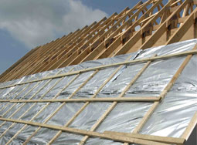
We are engaged in distributing and supplying Roofing Insulation. These insulation reflectors are manufactured by using polyethylene air bubble film (ABE) laminated with aluminum foil.

CONTACT US
Address For Communication
CIVIL DOCTOR
#12/20, SND Layout No II,
Tatabad,
Coimbatore-641012.
Email:mail.civildoctor@gmail.com
Email : coimbatore@civildoctor.com
Mobile: +91-9894600048, +91 9894171051
Phone:0422-4380064, 4380074
Contact us

requirement
Email
Name
Phone
inprogress

CLIENTS
- Authorized Dealer and Applicator for Sika India Pvt. Ltd.,
- Authorized Dealer for Supreme Expansion and Vibration Boards
- Authorized Stockiest and Applicator for Roff Construction Chemicals, Pidilite Industries
- Authorized Shoppe and Applicator for Dr.Fixit, Pidilite Industries
- Authorized Distributor and Applicator for CIDO Construction Chemicals,
- Authorized Applicator for Texsa, Spain (APP Membrane)
- Authorized Dealer and Applicator for STP (Shalimar Tar Products)
- Authorized Distributor for CIDOMLITE – Light Weight Filling Material
- Authorized Distributor for Tilestar, Tile Filling Grouts

